SFUSD Finance Model Use Case Summary

**Contents**

Summary 1

Purpose 1

Audience 1

Primary Use Cases - Budget Status Reports 2

Use Case 1: Financial Report to Inform Budget Status 2

Use Case 2: Financial Report to the California Department of Education 2

SFUSD Key Entities 3

Financial Model Proposed Guidelines 3

Technical Details 5

Proposed Finance Model UML 5

Ed-Fi Key Entities 5

Security 6

Additional Resources 6

# Summary

## Purpose

The purpose of this documentation is to provide an overview of the identified finance model use cases for SFUSD.

## Audience

This documentation is intended for both technical and non-technical SFUSD personnel interested in the implementation of a finance domain model based on the Ed-Fi Data Standard. The Technical Details portion of this document is intended for data modelers but may be useful to other stakeholders within the district involved in collecting and using the education finance data.

# Primary Use Cases - Budget Status Reports

SFUSD has identified two primary use cases for the finance data model. Both cover a Principal’s or Central Office Manager’s Budget Status Reports. The first financial report is intended to inform on budget status. The second financial report is to the California Department of Education.

## Use Case 1: Financial Report to Inform Budget Status

The financial report to inform budget status must include local accounts to track budget, full time equivalency (FTE) for staff, pre-encumbrance, encumbrance, expenditures, and available balances. Local accounts must map to the state’s Standardized Account Code Structure (SACS).

Within the SFUSD organization hierarchy, financial reports are expected for all cost centers. Cost centers may be instructional (i.e. schools), or a part of policy and operations departments (e.g., Finance Dept, Nutrition Dept, Technology Dept). Schools are grouped into Cohorts that then report to the Instructional Deputy Superintendent. Non-instructional cost centers are grouped by department or division that then report to the Policy and Operations Deputy Superintendent.

Payroll accounts for about 80% of the SFUSD’s expenses. The district must be able to track not only actual amounts but also budgeted amounts for each position and the full-time equivalency of these positions (i.e. position management). Position management should include the position number, position title, job classification, full time equivalency. Positions must be associated with organizations (both schools and non-instructional cost centers each year and these must be independent of the individual staff members which hold those positions throughout the year. Staff members that hold these positions would be then associated with the position management record.

SFUSD’s accounting software has built-in calculations for encumbrance and projections for local accounts. These values are derivable from existing data in the local entities, however, given the business logic is built into the existing software, SFUSD has requested these be included in the model.

At each level within the financial organization hierarchy, it is expected that leadership staff (e.g., Principal, Associate Superintendent) will have downstream access to the financial data associated with their organization or the organizations that report to them, and only that data which is associated with their organization or the organizations that report to them. For example, a Principal should only have access to financial data for their school while an Associate Superintendent in charge of a school cohort should have access to all financial data for schools within that cohort. Staff must be associated with each level within the organization hierarchy as they are defined in the SACS strings.

## Use Case 2: Financial Report to the California Department of Education

SFUSD is responsible for the financial reporting to the California Department of Education using the SACS report standard format.

The account code elements identified in SACS (i.e., Fund, Resource, Project Year, Goal, Function, Object, and Amount) must be defined in the model along with the types of financial data expected (i.e., Budget, Estimated Actuals, Unaudited Actuals, Original Budget, Board Approved Operating Budget, Actuals to Date, and Projected Totals).

SACS will occasionally deprecate an account code but SFUSD would like to have access to those records for longitudinal reporting and so an additional field for “IsObsolete” is needed in the account dimensions.

Both local and state account codes may be defined in a hierarchy where a state account code may have multiple “child accounts” that roll up to the parent account. A hierarchy needs to be possible in the accounts to allow for this more granular view. Local codes that are child accounts to a SACS state account are distinguished by a code source.

There are five reporting periods starting with Budget on July 1st, Unaudited Actuals, First Interim, Second Interim, and End of Year Projection. Each of these reporting periods requires that local accounts also be tracked by period.

## SFUSD Key Entities

* Local Accounts, including Budgets, Actuals, and Report Periods
* SACS Account Code Elements, Financial Data Types, and Report Periods
* Cost Centers, including Schools and Non-Instructional Organizations
* School Cohorts
* Departments and Divisions
* Policy & Operations Organization, headed by Deputy Superintendent
* Instructional Organization, headed by Deputy Superintendent
* Staff Assignments, FTE, and Payroll
* Staff Position Management

## Financial Model Proposed Guidelines

Based on the above requirements, it is proposed that SFUSD use the Ed-Fi Finance API extension model as a starting point. This model provides a framework to map local accounts to a state chart of accounts, to include staff and education organization references to local accounts, and to record both budgeted and actual values.

Additional elements will be required to align SFUSD needs with the data model. These are primarily around the following:

Schools have assigned cohorts which may change each year. School cohorts may be defined using the Ed-Fi EducationOrganizationNetwork entity with schools assigned to a cohort using the EducationOrganizationNetworkAssociation entity.

Entities that align with non-school cost centers (OrganizationDepartment) were not added to the Ed-Fi model until Data Standard v3.3.0-a. SFUSD is on an earlier version of the Ed-Fi Data Standard. Rather than extend the model, SFUSD may use LocalEducationAgency for these organizations and set the ParentLocalEducationAgency to the district.

Position Management (i.e., budgeted and actual payroll by position) is not included in the Chart of Accounts or Staff Payroll entities for the extended Ed-Fi Finance model. A new Position Management entity can hold position financial metadata that can then be associated with organizations (e.g., cost centers and schools), staff, and local accounts. Full time equivalency is an important piece of tracking payroll. Occasionally there are “buckets” of staff positions like Substitute Teachers where FTE may be over 100%. For this reason, FTE needs to be included in a few additional places outside of the new Position Management entity; namely StaffEducationOrganizationAssignmentAssociation, LocalBudgetPositionMangementAssociation, and LocalActualPositionManagementAssociation.

As mentioned, Encumbrance and Projections are data readily available from SFUSD’s accounting software and so these tables may also be included for ease of access in the ODS without having to duplicate the business logic in the backend for reporting.

Security configuration will be required for both data going into the ODS from the financial source systems and for data coming out of the ODS for reporting. Details around both can be found in the Security section of this document.

# Technical Details

## SFUSD Finance Model UML

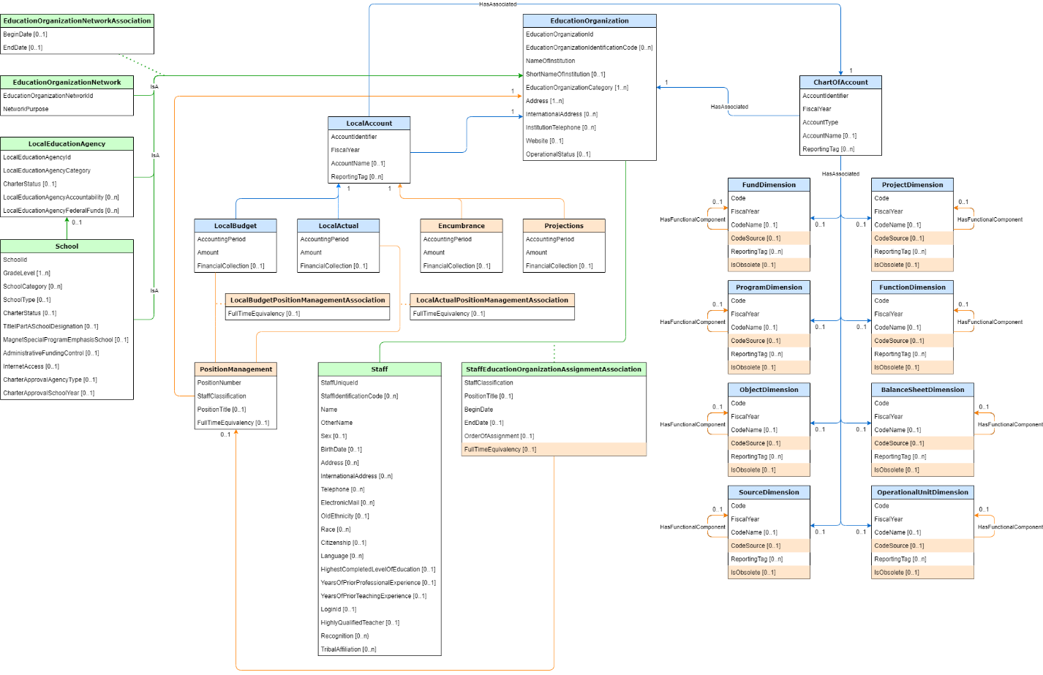

## Ed-Fi Key Entities

### LocalAccount including LocalBudget, LocalActual, Projection, and Encumbrance

This is the primary entity that will collect local financial account information.

### Staff including Payroll and new PositionManagement

Staff payroll and position management are important inputs to local accounts as this is the largest piece of the district’s annual budget. Position Management is an extension designed for SFUSD that will hold budgeted amounts for staff based on position numbers, full time equivalency, and employment periods.

### ChartOfAccount and Dimensions

The California Department of Education SACS can be mapped directly to the Chart of Accounts and Dimension entities. There may need to be a new dimension for Position Numbers.

### Organization Hierarchy

The SFUSD model has an organization hierarchy under the district that goes beyond what Ed-Fi supports in the core model.

#### CostCenter

Non-school cost centers are not currently a part of the Ed-Fi core model. District departments are comprised of multiple cost centers which each have their own finance data. LocalEducationAgency will hold the non-school cost centers with an expectation to move to OrganizationDepartments in a future upgrade.

#### School Cohorts

The Ed-Fi model has the concept of EducationOrganizationNetwork which allows the district to define School Cohorts as networks and then assign schools to these networks via the EducationOrganizationNetworkAssociation.

# Security

### Data In

Data going into the ODS would have security set at the district-level. Given the financial data source systems are the same across the district’s organization hierarchy (two versions of PeopleSoft), this will allow all organizations to submit their financial data under the district umbrella.

### Data Out

Data pulled from the ODS to power reports and visualizations will need to be organized in such a way to restrict access based on a user’s role within the district.

The Ed-Fi “out of the box” API security is designed to handle security by systems and not individuals. Best practice is to use the downstream applications to handle user access security configuration. In the case of SFUSD, this is current SSRS with an expected transition to Tableau in the future.

Additional references to associate the appropriate Staff with cost centers, departments, and school cohorts may be required to configure the user access.

# Additional Resources

Ed-Fi RFC 18 – Finance API:

<https://techdocs.ed-fi.org/display/EFDSRFC/ED-FI+RFC+18+-+FINANCE+API>

California Department of Education Standardized Account Code Structure:

<https://www.cde.ca.gov/fg/ac/ac/>